

2 Minute Form
Trip Name: Whangaparaoa Coast to Coast
Check-in Name and Phone:
Date: Branch:
Leaders |  |  |  |  |  |  |  |  |  |  | Joya Todd
Cell Phone Number |  |  |  |  |  |  |  |  |  |  | 0210469036
VHF Call Sign &/or Vessel Name
Vehicle make, model, registration, colour
General Plan
Note: If plan changes, you must notify your Check-in person.
Latest Time Off the Water |  |  |  |  |  |  |  |  |  |  | TMP used²⁰
Tide/ Forecast Lake Level | Low |  |  | High |  |  |  |  |  |  | Other
Communications Carried²¹ | VHF and Cell Ph
Communications | CH 82 (Nth Side) and 80 (Sth Side ) for coastguard. Ch 8 intergroup |  |  |  |  |  |  |  |  | We will be communicating as a group on VHF Channel _____
Equipment Carried | Standard Day Paddling and helmets when rock gardening if any significant swell
Trip Report
(Use other side if more space required)

Activity | Wednesday Paddle | Centre | North Shore | Location North Shore |  |  |  |  | Difficulty¹ |  |  | Intermediate
Activity Description | Paddle around the end of Whangaparaoa Peninsula |  |  |  | Leader qualification req.² |  | YES
Get in Location | Tindalls Beach or Matakatia Bay |  |  |  | Chart/ Map no.⁴ |  | NZ532 *** |  | Distance |  |  | 20K
Get out Location | Matakatia Bay or Tindalls Beach |  |  |  | Coastguard Channel |  | 80,82 & 16 |  | Nowcasting |  |  | 20,21,22
Emergency get out ⁵ | Gulf Harbour, Shakespear Bay, small beaches on way, Army Bay |  |  |  | Emergency / Coastguard Station |  | Auckland |  | Phone |  |  | *500  09 303 4303
Emergency get out ⁵ |  |  |  |  | Drinking Water⁶ | Take Own |  | Toilets⁷ |  |  | All public Bays
Emergency Response | Refer Emergency Response Booklet |  |  |  |  |  |  | Parking⁸ |  |  | Plenty by beaches
Specific Equipment Required⁹ | Standard Day Paddle plus Helmets recommended. |  |  |  | Working Communications equipment in this area¹⁰ | Cell phone  Sat phone |  |  |  |  |  |  | PLB  VHF
Other resources  and notes¹¹ |  |  |  |  | Weather Parameters¹² | Max 15 K steady gusting 20K
Previous incidents¹³

Safety Management¹⁴
Hazard |  | Significant?  - E/I/M |  | Management Strategy¹⁵ |  |  |  | Hazard | Significant?  - E/I/M | Management Strategy¹⁵
Cold Water |  | Yes - M |  | Carry spare dry clothes and shelter |  |  |  | Deep Water | Yes - E | Correctly fit PFDs
Medical Conditions |  | Yes - M |  | - Leader has first aid qualification  - Ask customers about medical conditions |  |  |  | Bad Weather | Yes - M | Understand weather forecasts.  Have back up plans or pull out if necessary
Capsizing |  | Yes - M |  | - Correctly fit PFDs  - Skills at performing rescues. |  |  |  | Heat / Sun | Yes - M | - Protective Clothing (worn), Sunglasses, Hat  - Sun Screen  - Plenty of drinks
Panic |  | Yes - M |  | Ensure conditions match level  of skills |  |  |  | Obstacles | Yes - M | Awareness of reefs, navigational hazards, nets
Strong Currents in Channel |  | Yes- M |  | - Stay close to shore where possible |  |  |  | Other Vessels | Yes - M | - Understand the “rules of the sea”  - “Be seen” – Have two of the following; flag, brightly coloured kayak, brightly coloured Pfd or hat. At night: an all- round white light & a powerful torch.
 |  |  |  |  |  |  |  | Boat traffic esp near Gulf Harbour | Yes - M | Group up and wait for gaps
Live Firing |  | Yes - E |  | Army Bay is adjacent to army land. They frequently have shooting practice using live rounds. If this is on, they generally post a very small notice on the gate near the top of the boat ramp, so always check there. They also fly red flags on poles located along the top of the cliffs visible from the water. If there is a sign posted, or the red flags are flying, you are required to paddle well out from the coast – can’t remember the exact distance, may be about 500m out from the coast.
Written up by: | R Saysell |  | Approved By: |  | Rob Howarth | Signed: |  |  | Date: | 26/5/2014 | Review in: | 12 months from date of approval

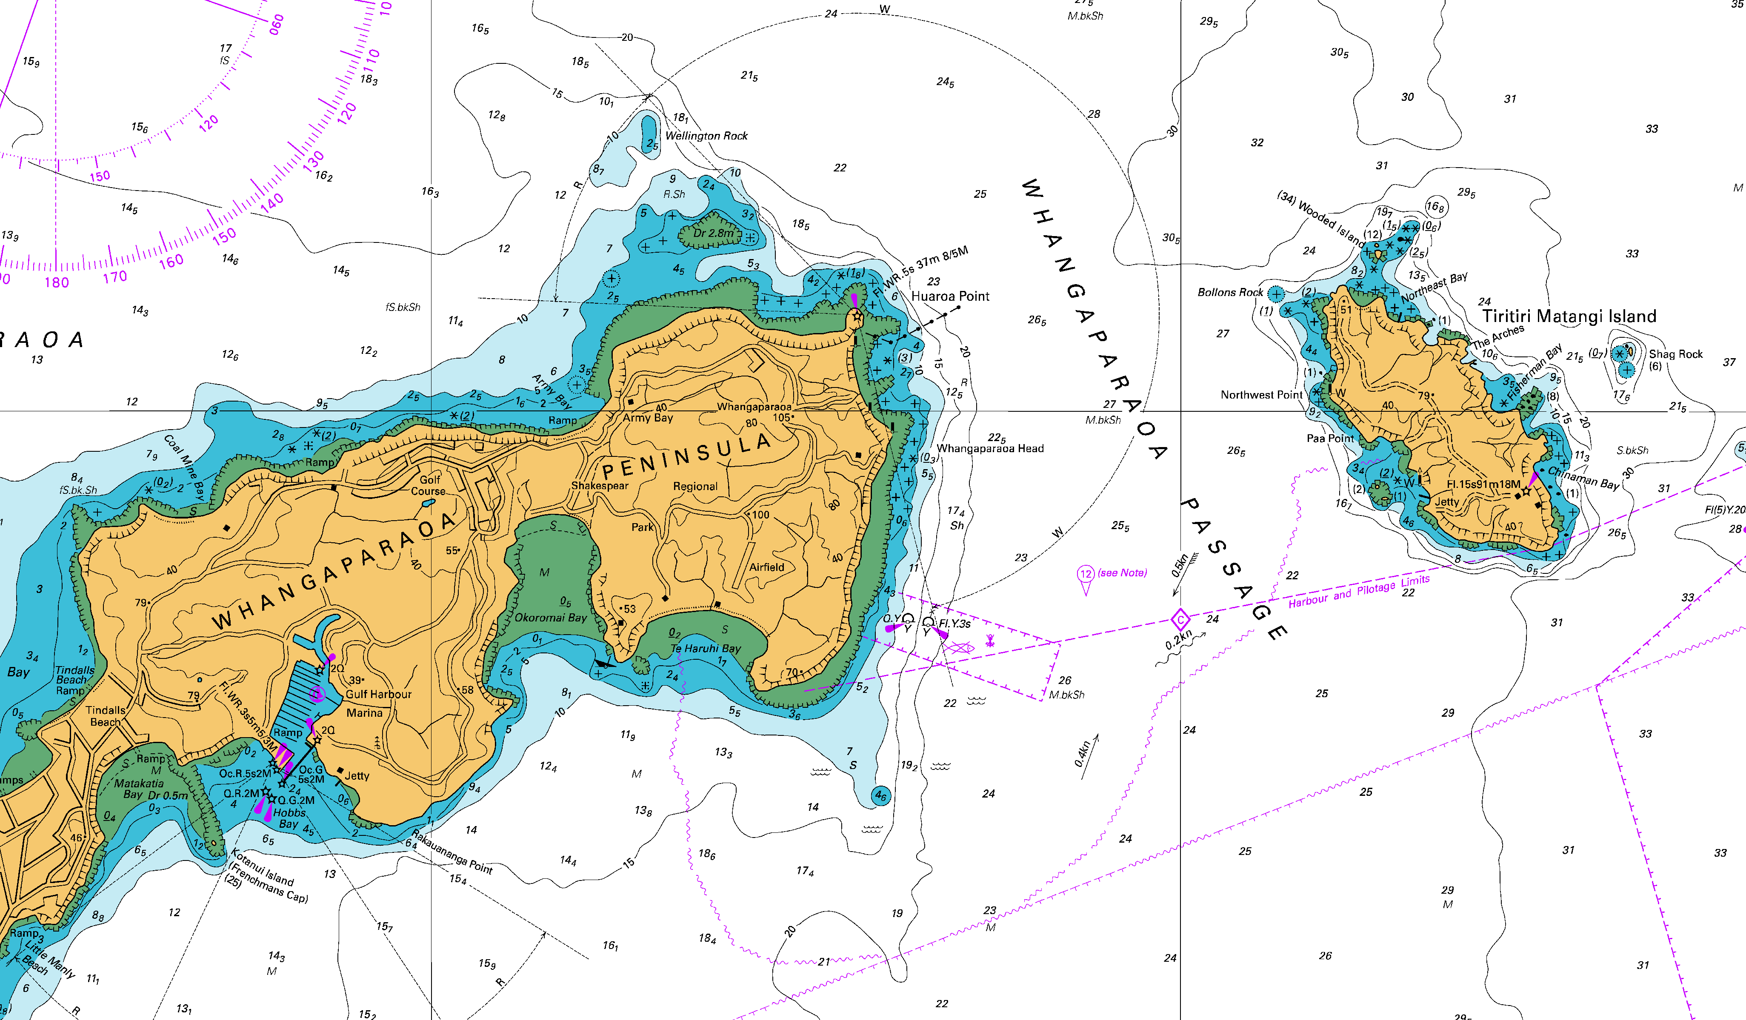

Additional Information Sheet (Optional)
Introduction (A general introduction)
Description (A description of the tour – as if you were selling the idea to someone)
Local Attractions |  | Transport/ Local Operators
 | Contact details |  | Contact details
Local Eateries
 | Contact details
Accommodation/ Campsite Locations |  |  | Facilities
Name |  |  | Cabins |  | Fuel
Phone |  |  | Showers |  | Power
E-mail |  |  | Toilets |  | Water Access
Website |  |  | Laundry |  | Pool
Physical Address |  |  | Water |  | Fires Allowed
Other |  |  | Supplies
Other information

Activity Equipment Check list
Equipment List
xHelmet (rivers & surf) Group Gear
 Beanie / hat  Split paddles
 Thermals  Repair kit
 Paddle Jacket  Fire lighting
 PFD  Cooker/thermos
 Spray deck  Spare thermals
 Booties  Tow system
 Water & food  1st Aid Kit
 Kayak & paddle  Flares
Group - Oceans & Lakes  Compass
❑ Pumps & Paddle Floats  Charts / Maps
Group - River  GPS (optional)
❑ Throw ropes  Knife (cut rope)
❑ Pin kit & saw  Emergency Shelter

In case of emergency: Dial 111, Mayday :VHF Channel 16

Kayaking Check list

 Trip plan
 Latest weather forecast
 Conditions match skills?
 Hyperthermia (hot) &
Hypothermia (cold)
 On & off water safety
 Environmental concerns
 Emergency Procedures include emergency get out.
 Working communication devices
e.g. VHF radio, mobile phones, PLB
 Specific safety issues for this trip
 Participant list
 Any medical conditions
 All participants keen to proceed?

 Trip Plan/ 2-minute form lodged with Ops. Manager

Appropriate wind conditions to run trips:
Novice - no significant surf or swell, wind under 15knots
Intermediate- surf or ocean swells less than 1.5 meter or wind under 25 knots.
Advanced- any condition that is suitable to the trips aims

At conclusion of trip:
Contact check in person
Group Debrief.

Check in Person Ph:021925489
_____021925489__ Mobile
____094791002_____ Work
__________________ Home

Activity Document Cover Sheet

Activity: Wednesday Paddle around Whangaparaoa
Date of Activity: 28 May
WHEN ARE WE SUPPOSED TO FILL THIS IN. CERTAINLY CANT DO THIS AT THIS POINT. AN EXAMPLE OF THE MUDDIED THINKING GOING INTO THIS ALL IN ONE TMP. ALSO HOW CAN YOU SIGN AN ON LINE DOC.

Activity reports. Is all relevant information present: | No
– Approved Trip Management Plan (TMP)/ 2 minute form | No
– Club Trip Participant Sheet | No
– Weather forecast | No
– Activity Check List | YES
– Trip report (May be on the 2 minute form) | NO
– Accident / incident reports | NO
Leaders Signature:R SAYSELL
Date:23/5/14

